**How to Add Hubot to Flowdock**

1. first of all , you must be the administator of an organization.
2. Create a Hubot account for an organization at <https://www.flowdock.com/account>

click user which organization you want to add hubot

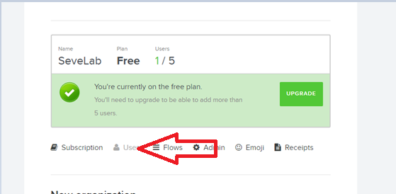

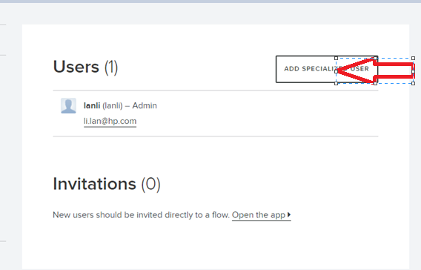

You may use a google email to ctreate it.

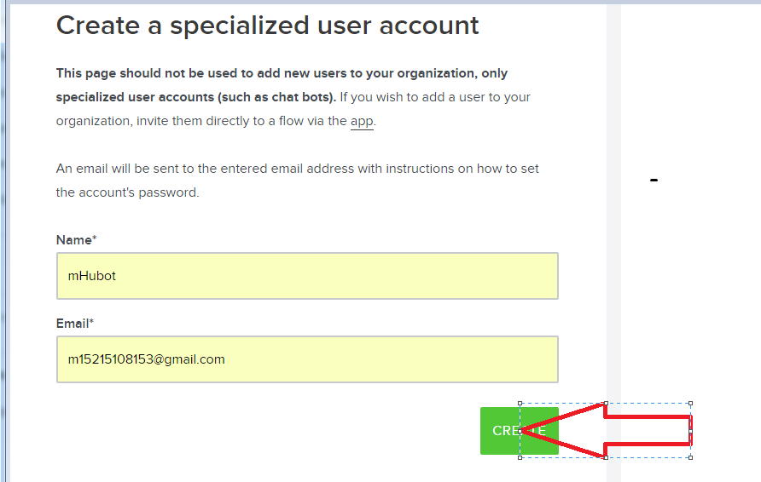

The add it to the group

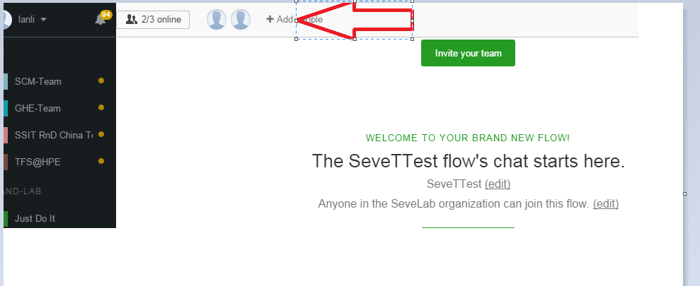

1. Go to your email to reset your password , and use it to login flowdock to get the API tocken

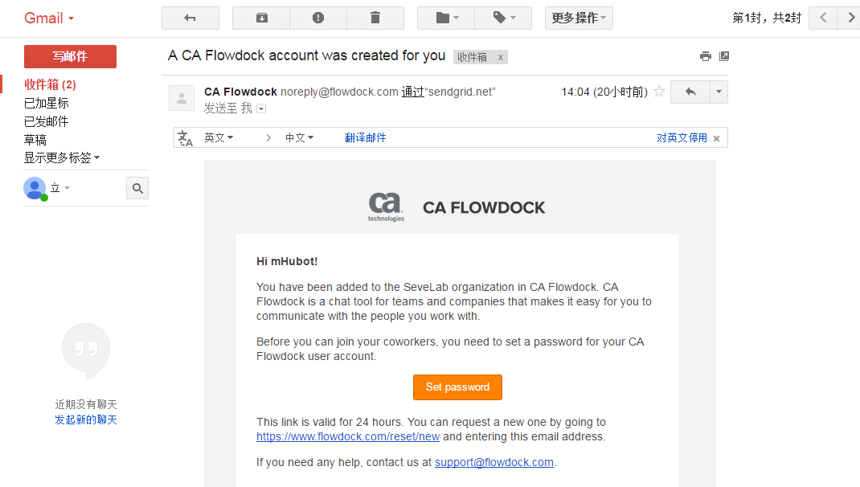

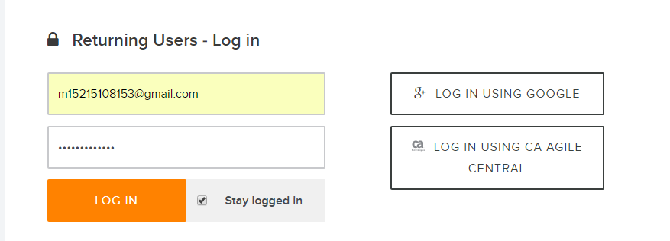

Go to there <https://www.flowdock.com/account/tokens>

Copy the token

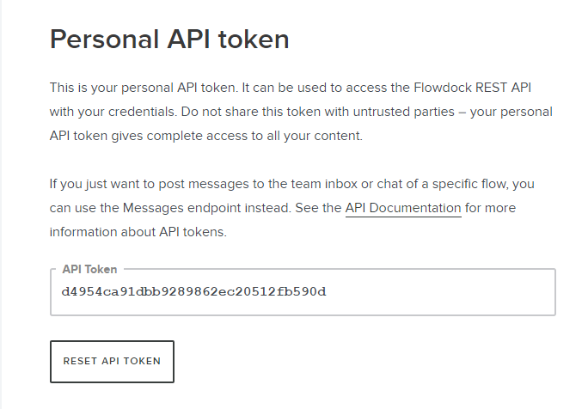

1. Install hubot on your machine
2. Su to the root

sudo su

1. Set the proxy

export http_proxy=http://proxy.houston.hpecorp.net:8080

export https_proxy=http://proxy.houston.hpecorp.net:8080

1. Install node.js and npm

Ubantu:

curl -sL https://deb.nodesource.com/setup_4.x | sudo -E bash -

apt-get install -y nodejs

Redhat:

curl --silent --location https://rpm.nodesource.com/setup_4.x | bash -

yum install -y gcc-c++ make

yum -y install nodejs

1. Install hubot

npm install -g yo generator-hubot

**exit**

export http_proxy=http://proxy.houston.hpecorp.net:8080

export https_proxy=http://proxy.houston.hpecorp.net:8080

mkdir mHubot

cd mHubot

yo hubot --owner="Seve <m15215108153@gmail.com>" --name="mHubot" --description="a robot of seve" --adapter=flowdock –defaults

1. Set the hubot startup

Copy this shell to the file /etc/init.d/hubot , you need to reset the path

#!/bin/sh

# This assumes you have:

# 1) A user called `hubot` in charge of the bot.

# 2) A file called /home/hubot/.hubotrc that contains the Hubot credentials.

#

# To set the adapter either edit bin/hubot to specify what you want or append

# `-- -a campfire` to the $DAEMON variable below.

#

### BEGIN INIT INFO

# Provides: hubot

# Required-Start: $all

# Required-Stop: $all

# Default-Start: 2 3 4 5

# Default-Stop: 0 1 6

# Short-Description: starts the hubot service

# Description: starts the Hubot bot for the Campfire rooms

### END INIT INFO

HUBOT_HOME="/opt/mount2/hubot/mHubot"

DAEMON="$HUBOT_HOME/bin/hubot"

DAEMONOPTS="--name mHubot --adapter flowdock"

NAME=hubot

USER=llan1

DESC="mRobot"

LOGFILE=/var/log/hubot/$NAME.log

PIDFILE=/var/run/$NAME.pid

SCRIPTNAME=/etc/init.d/$NAME

# Save Environement Variables

source $HUBOT_HOME/hubot.env

case "$1" in

start)

printf "%-50s" "Starting $DESC..."

cd $HUBOT_HOME

PID=`runuser -c "$DAEMON $DAEMONOPTS" $USER >> $LOGFILE 2>&1 & echo $!`

#echo "Saving PID" $PID " to " $PIDFILE

if [ -z $PID ]; then

printf "%s\n" "Fail"

else

echo $PID > $PIDFILE

printf "%s\n" "Ok"

fi

;;

status)

printf "%-50s" "Checking $DESC..."

if [ -f $PIDFILE ]; then

PID=`cat $PIDFILE`

if [ -z "`ps axf | grep ${PID} | grep -v grep`" ]; then

printf "%s\n" "Process dead but pidfile exists"

else

echo "Running"

fi

else

printf "%s\n" "Service not running"

fi

;;

stop)

printf "%-50s" "Stopping $DESC"

if [ -f $PIDFILE ]; then

PID=`cat $PIDFILE`

kill $PID

printf "%s\n" "Ok"

rm -f $PIDFILE

else

printf "%s\n" "pidfile not found"

fi

;;

restart)

$0 stop

$0 start

;;

*)

echo "Usage: $0 {status|start|stop|restart}"

exit 1

esac

sudo su

mkdir /var/log/hubot

cd /var/log/hubot

touch hubot.log

1. Set the hubot env

exit

cd mHubot

vi hubot.env

export PATH=$PATH:/usr/local/bin

export http_proxy=http://web-proxy.houston.hp.com:8080

export https_proxy=http://web-proxy.houston.hp.com:8080

export HUBOT_LOG_LEVEL=debug

export HUBOT_FLOWDOCK_API_TOKEN=( what you get from step 3)

1. Start hubot

/etc/init.d/hubot start